**Add Bookmarks and Buttons**

**Add bookmarks**

In this task you will add two bookmarks, one to display each of the monthly sales/targets visuals.

1. Go to the **My Performance** page.
2. On the **View** ribbon tab, from inside the **Show Panes** group, click **Bookmarks**.

[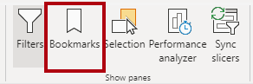](https://github.com/MicrosoftLearning/DA-100-Analyzing-Data-with-Power-BI/blob/master/Instructions/Labs/Linked_image_Files/08-design-report-in-power-bi-desktop-enhanced_image39.png)

1. On the **View** ribbon tab, from inside the **Show Panes** group, click **Selection**.

[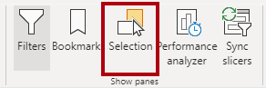](https://github.com/MicrosoftLearning/DA-100-Analyzing-Data-with-Power-BI/blob/master/Instructions/Labs/Linked_image_Files/08-design-report-in-power-bi-desktop-enhanced_image40.png)

1. In the **Selection** pane, beside one of the **Sales and Target by Month** items, to hide the visual, click the eye icon.

[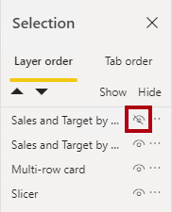](https://github.com/MicrosoftLearning/DA-100-Analyzing-Data-with-Power-BI/blob/master/Instructions/Labs/Linked_image_Files/08-design-report-in-power-bi-desktop-enhanced_image41.png)

1. In the **Bookmarks** pane, click **Add**.

[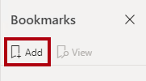](https://github.com/MicrosoftLearning/DA-100-Analyzing-Data-with-Power-BI/blob/master/Instructions/Labs/Linked_image_Files/08-design-report-in-power-bi-desktop-enhanced_image42.png)

1. To rename the bookmark, double-click the bookmark.
2. If the visible chart is the bar chart, rename the bookmark as **Bar Chart ON**, otherwise rename the bookmark as **Column Chart ON**.
3. To edit the bookmark, in the **Bookmarks** pane, hover the cursor over the bookmark, click the ellipsis, and then select **Data**.

[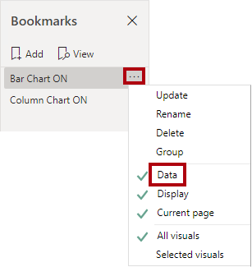](https://github.com/MicrosoftLearning/DA-100-Analyzing-Data-with-Power-BI/blob/master/Instructions/Labs/Linked_image_Files/08-design-report-in-power-bi-desktop-enhanced_image43.png)

*Disabling the****Data****option means the bookmark won’t use the current filter state. That’s important because otherwise the bookmark would permanently lock in the filter currently applied by the****Year****slicer.*

1. To update the bookmark, click the ellipsis again, and then select **Update**.

[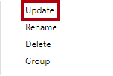](https://github.com/MicrosoftLearning/DA-100-Analyzing-Data-with-Power-BI/blob/master/Instructions/Labs/Linked_image_Files/08-design-report-in-power-bi-desktop-enhanced_image44.png)

*In the following steps, you’ll create and configure a second bookmark to show the second visual.*

1. In the **Selection** pane, toggle the visibility of the two **Sales and Target by Month** items.

*In other words, make the visible visual hidden, and make the hidden visual visible.*

[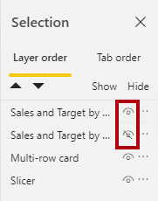](https://github.com/MicrosoftLearning/DA-100-Analyzing-Data-with-Power-BI/blob/master/Instructions/Labs/Linked_image_Files/08-design-report-in-power-bi-desktop-enhanced_image45.png)

1. Create a second bookmark, and name it appropriately (either **Column Chart ON** or **Bar Chart ON).**

[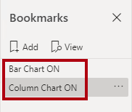](https://github.com/MicrosoftLearning/DA-100-Analyzing-Data-with-Power-BI/blob/master/Instructions/Labs/Linked_image_Files/08-design-report-in-power-bi-desktop-enhanced_image46.png)

1. Configure the second bookmark to ignore filters (**Data** option off), and update the bookmark.
2. In the **Selection** pane, to make both visuals visible, simply show the hidden visual.
3. Resize and reposition both visuals so they fill the page beneath the multi-card visual, and completely overlap one another.

*Tip: To select the visual that is covered up, select it in the****Selection****pane.*

[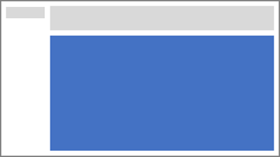](https://github.com/MicrosoftLearning/DA-100-Analyzing-Data-with-Power-BI/blob/master/Instructions/Labs/Linked_image_Files/08-design-report-in-power-bi-desktop-enhanced_image47.png)

1. In the **Bookmarks** pane, select each of the bookmarks, and notice that only one of the visuals is visible.

*The next stage of design is to add two buttons to the page, which will allow the report user to select the bookmarks.*

**Add buttons**

In this task you will add two buttons, and assign bookmark actions to each.

1. On the **Insert** ribbon, from inside the **Elements** group, click **Button**, and then select **Blank**.

[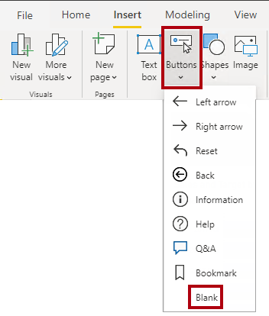](https://github.com/MicrosoftLearning/DA-100-Analyzing-Data-with-Power-BI/blob/master/Instructions/Labs/Linked_image_Files/08-design-report-in-power-bi-desktop-enhanced_image48.png)

1. Position the button directly beneath the **Year** slicer.
2. Select the button, and then in the **Visualizations** pane, turn the **Button Text** property to **On**.

[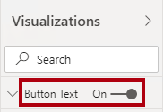](https://github.com/MicrosoftLearning/DA-100-Analyzing-Data-with-Power-BI/blob/master/Instructions/Labs/Linked_image_Files/08-design-report-in-power-bi-desktop-enhanced_image49.png)

1. Expand the **Button Text** section, and then in the **Button Text** box, enter **Bar Chart**.
2. Expand the **Background** section, and then set a background color using a complementary color.
3. Turn the **Action** property to **On** (located near the bottom of the list).

[Picture 127](https://github.com/MicrosoftLearning/DA-100-Analyzing-Data-with-Power-BI/blob/master/Instructions/Labs/Linked_image_Files/08-design-report-in-power-bi-desktop-enhanced_image50.png)

1. Expand the **Action** section, and then set the **Type** dropdown list to **Bookmark**.
2. In the **Bookmark** dropdown list, select **Bar Chart ON**.

[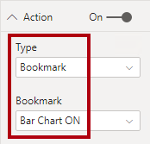](https://github.com/MicrosoftLearning/DA-100-Analyzing-Data-with-Power-BI/blob/master/Instructions/Labs/Linked_image_Files/08-design-report-in-power-bi-desktop-enhanced_image51.png)

1. Create a copy of the button by using copy and paste, and then configure the new button as follows:

*Tip: The shortcut commands for copy and paste are****Ctrl+C****followed by****Ctrl+V****.*

* + Set the **Button Text** property to **Column Chart**
  + In the **Action** section, set the **Bookmark** dropdown list to **Column Chart ON**

*The design of the Sales Analysis report is now complete.*

**Publish the report**

In this task you will publish the report.

1. Select the **Overview** page.
2. In the **Year** slicer, select **FY2020**.
3. In the **Region** slicer, select **Select All**.
4. Save the Power BI Desktop file.

*The file must always be saved prior to publishing to the Power BI service.*

1. On the **Home** ribbon tab, from inside the **Share** group, click **Publish**.

[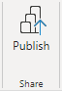](https://github.com/MicrosoftLearning/DA-100-Analyzing-Data-with-Power-BI/blob/master/Instructions/Labs/Linked_image_Files/08-design-report-in-power-bi-desktop-enhanced_image52.png)

1. In the **Publish to Power** BI window, notice that **My Workspace** is selected.
2. To publish the report, click **Select**.

[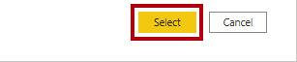](https://github.com/MicrosoftLearning/DA-100-Analyzing-Data-with-Power-BI/blob/master/Instructions/Labs/Linked_image_Files/08-design-report-in-power-bi-desktop-enhanced_image53.png)

1. If prompted to replace the dataset, click **Replace**.
2. When the publication has succeeded, click **Got It**.

[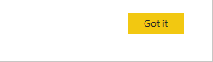](https://github.com/MicrosoftLearning/DA-100-Analyzing-Data-with-Power-BI/blob/master/Instructions/Labs/Linked_image_Files/08-design-report-in-power-bi-desktop-enhanced_image54.png)

1. Close Power BI Desktop open.

*You’ll explore the report in the Power BI service in the next exercise.*

**Exercise 5: Explore the Report**

In this exercise you will explore the report in the Power BI service.

**Explore the report**

In this task you will explore the report in the Power BI service.

1. In the Microsoft Edge browser window, in the Power BI service, in the **Navigation** pane, click the **Sales Analysis** report.
2. To test the drill through report, in the **Overview** page, in the **Quantity by Category** visual, right-click the **Clothing** bar, and then select **Drill Through | Product Details**.

[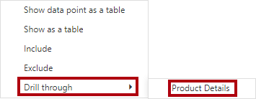](https://github.com/MicrosoftLearning/DA-100-Analyzing-Data-with-Power-BI/blob/master/Instructions/Labs/Linked_image_Files/08-design-report-in-power-bi-desktop-enhanced_image55.png)

1. Notice that the **Product Details** page is for **Clothing**.
2. To return to the source page, at the top-left corner of the page, click the arrow button.
3. Select the **My Performance** page.
4. Click each of the buttons, and then notice that a different visual is displayed.

**Finish up**

In this task you will complete the lab.

1. To return to your workspace, in the banner across the window web page, click **My Workspace**.

[Picture 23](https://github.com/MicrosoftLearning/DA-100-Analyzing-Data-with-Power-BI/blob/master/Instructions/Labs/Linked_image_Files/08-design-report-in-power-bi-desktop-enhanced_image56.png)

1. Leave the Microsoft Edge browser window open.
2. In Power BI Desktop, go to the **My Performance** page, and then in the **Filters** pane, remove the **Salesperson** filter card.

[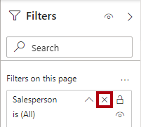](https://github.com/MicrosoftLearning/DA-100-Analyzing-Data-with-Power-BI/blob/master/Instructions/Labs/Linked_image_Files/08-design-report-in-power-bi-desktop-enhanced_image57.png)

1. Select the **Overview** page.
2. Save the Power BI Desktop file, and then republish the report to Power BI.